# Cascade Solar Energy Systems

Different types of collectors and different forms of electricity generation are suitable for different working temperature zones with different costs. A prototype of cascade collection and cascade utilization of solar energy with high efficiency and low cost is presented. Parabolic trough collectors are used to collect low temperature energy with low cost and dish collectors are used to collect high temperature energy with high efficiency. Rankine cycle is used to work in low temperature zone and Stirling cycle is used to work in high temperature zone. Furthermore, effective topological structures are considered to take full advantages of thermodynamic characters of different components of the system. The cold chamber of Stirling engine is cooled by condensed fluid of Rankine cycle to use the heat produced by Stirling engine.

Several types of cascade solar energy systems are designed. Two typical systems are briefly introduced as below.

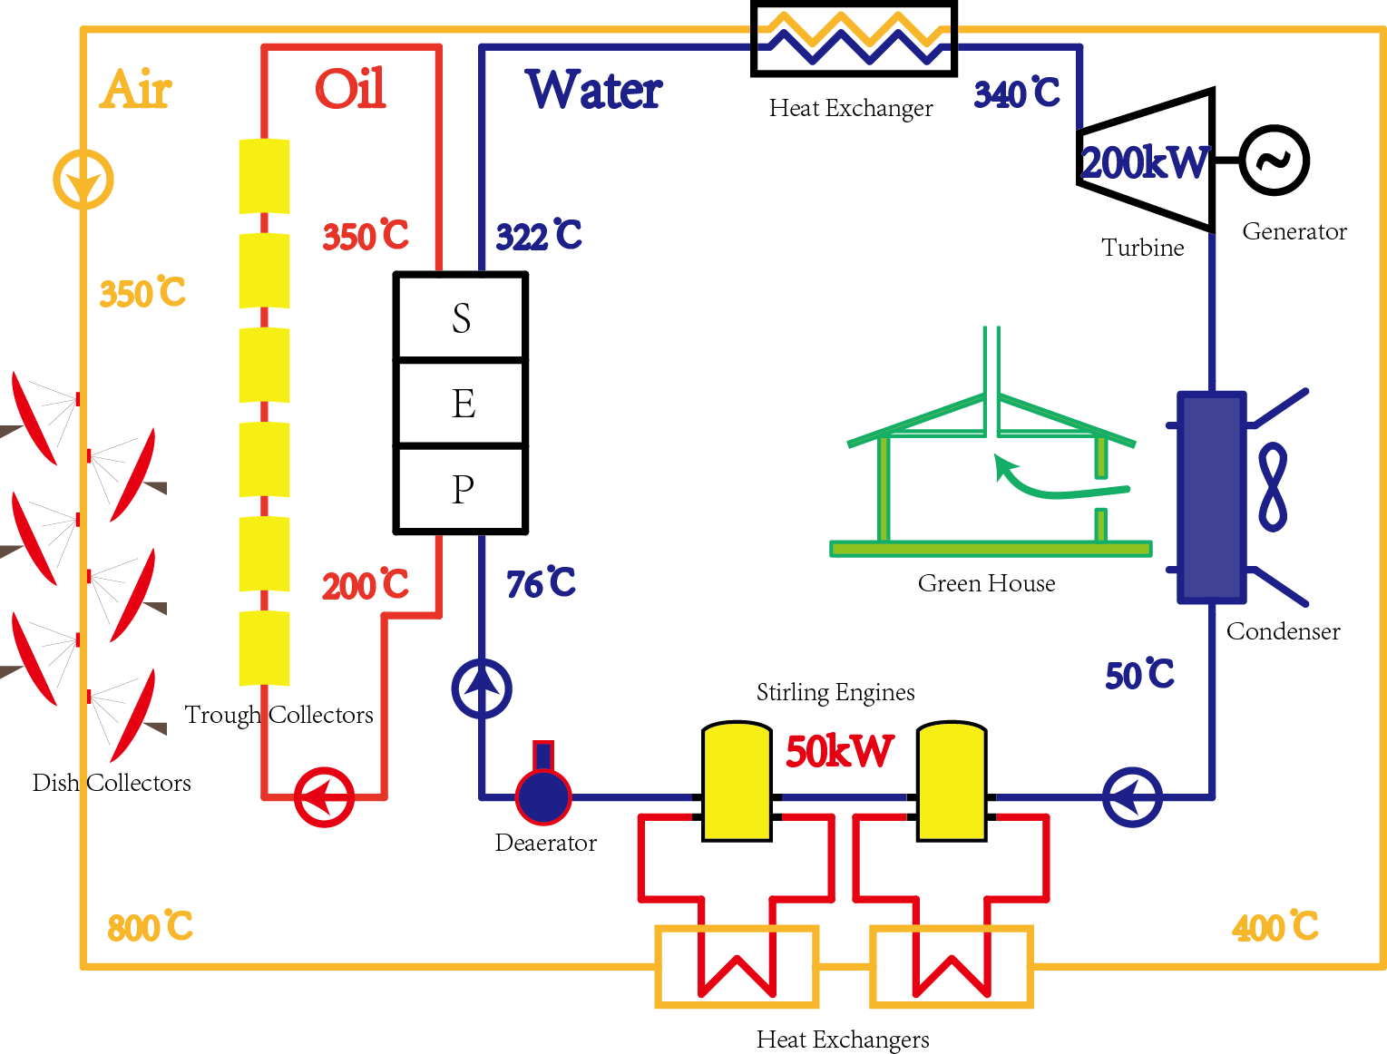

Figure Cascade system using water as working fluid

In Figure 1, water is used as the working fluid of Rankine cycle. S represents the superheater; E represents the evaporator; P represents the preheater. Dish collectors are used to gain high temperature pressed air (about 800℃ at the outlet), and the air is sent to heat the hot chamber of Stirling engine and the main steam of Rankine cycle. Trough collectors are used to gain high temperature oil (about 350℃ at the outlet), and the oil is sent to preheat, evaporate and superheat the feedwater. And a green house with a hot air chimney is used to collect the condensation heat of the condenser. The cold chamber of Stirling engine is cooled by feed water of Rankine cycle.

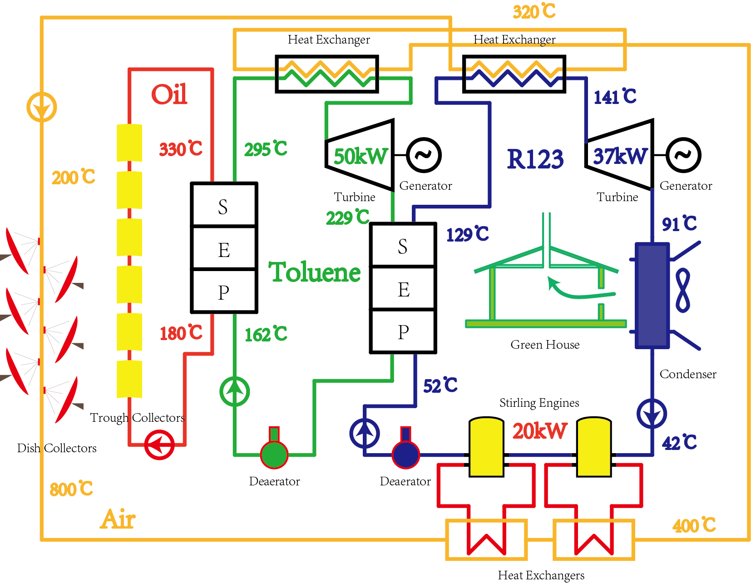

Figure Cascade system using organic fluids as working fluids

In Figure 2, toluene and R123 are used as the working fluids of Rankine cycle. S represents the superheater; E represents the evaporator; P represents the preheater. Dish collectors are used to gain high temperature pressed air (about 800℃ at the outlet), and the air is sent to heat the hot chamber of stirling engine and the main steam of both Rankine cycles. Trough collectors are used to gain high temperature oil (about 350℃ at the outlet), and the oil is sent to preheat, evaporate and superheat toluene. The condensation heat of toluene is used to preheat, evaporate and superheat R123. And a green house with a hot air chimney is used to collect the condensation heat of R123. The cold chamber of Stirling engine is cooled by condensed R123.

The theoretical model of the system are established by using OOP (Object Oriented Programming) method of MATLAB. Thermodynamic properties of the fluids are acquired by querying REFPROP 9.0 developed by the National Institute of Standards and Technology (NIST). A whole system is divided into several parts, such as collector field, generating set, and control system. Each part is optimized according to its own mechanism. All the parts are assembled together effectively to get different topological structures. MATLAB Simulink tools are used to set up the system model based on the equations depend on different situations. Modern optimal methods (Single goal optimal methods and multiple optimal methods) are used to get the optimized parameters for different goals.

More detailed mechanism of some parts (such as the Stirling engine and dish collector) of the systems needs to be studied to get more accurate models. More detailed cost of each component needs to be considered to accomplish the economic analysis of the system.

Control system (such as sun tracking system and system operation strategy) will be considered, and heat storage system may be used in the real test power system.